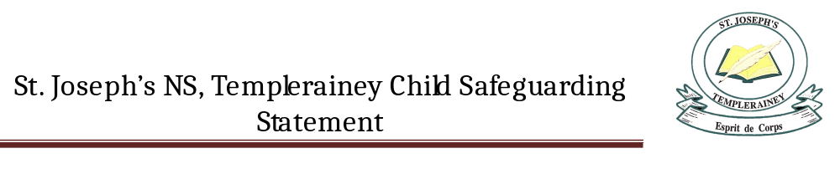St. Joseph’s NS is a primary school providing primary education to pupils from Junior Infants to Sixth Class and 2 years’ pre-school education to children attending our pre-school class for children with autism.
In accordance with the requirements of the Children First Act 2015, Children First: National Guidance for the Protection and Welfare of Children 2017, the Child Protection Procedures for Primary and Post Primary Schools 2017 and Tusla Guidance on the preparation of Child Safeguarding Statements, the Board of Management of St. Joseph’s NS has agreed the Child Safeguarding Statement set out in this document.

- The Board of Management has adopted and will implement fully and without modification the Department’s Child Protection Procedures for Primary and Post Primary Schools 2017 as part of this overall Child Safeguarding Statement

- The Designated Liaison Person (DLP) is Máire Daltúin

- The Deputy Designated Liaison Person (Deputy DLP is Jimmy Doyle

- The Board of Management recognises that child protection and welfare considerations permeate all aspects of school life and must be reflected in all of the school’s policies, procedures, practices and activities. In its policies, procedures, practices and activities, the school will adhere to the following principles of best practice in child protection and welfare:

The school will:
- recognise that the protection and welfare of children is of paramount importance, regardless of all other considerations;
- fully comply with its statutory obligations under the Children First Act 2015 and other relevant legislation relating to the protection and welfare of children;
- fully co-operate with the relevant statutory authorities in relation to child protection and welfare matters
- adopt safe practices to minimise the possibility of harm or accidents happening to children and protect workers from the necessity to take unnecessary risks that may leave themselves open to accusations of abuse or neglect;
- develop a practice of openness with parents and encourage parental involvement in the education of their children; and
- fully respect confidentiality requirements in dealing with child protection matters.

The school will also adhere to the above principles in relation to any adult pupil with a special vulnerability.
- The following procedures/measures are in place:

- In relation to any member of staff who is the subject of any investigation (howsoever described) in respect of any act, omission or circumstance in respect of a child attending the school, the school adheres to the relevant procedures set out in Chapter 7 of the Child Protection Procedures for Primary and Post-Primary Schools 2017 and to the relevant agreed disciplinary procedures for school staff which are published on the DES website.

- In relation to the selection or recruitment of staff and their suitability to work with children, the school adheres to the statutory vetting requirements of the National Vetting Bureau (Children and Vulnerable Persons) Acts 2012 to 2016 and to the wider duty of care guidance set out in relevant Garda vetting and recruitment circulars published by the DES and available on the DES website.

- In relation to the provision of information and, where necessary, instruction and training, to staff in respect of the identification of the occurrence of harm (as defined in the 2015 Act) the school-

- Has provided each member of staff with a copy of the school’s Child Safeguarding Statement
- Ensures all new staff are provided with a copy of the school’s Child Safeguarding Statement
- Encourages staff to avail of relevant training
- Encourages Board of Management members to avail of relevant training
- The Board of Management maintains records of all staff and Board member training

- In relation to reporting of child protection concerns to Tusla, all school personnel are required to adhere to the procedures set out in the Child Protection Procedures for Primary and Post-Primary Schools 2017, including in the case of registered teachers, those in relation to mandated reporting under the Children First Act 2015.

- In this school the Board has appointed the above named DLP as the “relevant person” (as defined in the Children First Act 2015) to be the first point of contact in respect of the child safeguarding statement.

- All registered teachers employed by the school are mandated persons under the Children First Act 2015.

- In accordance with the Children First Act 2015, the Board has carried out an assessment of any potential for harm to a child while attending the school or participating in school activities. A written assessment setting out the areas of risk identified and the school’s procedures for managing those risks is attached as an appendix to this statement.

- The various procedures referred to in this Statement can be accessed via the school’s website, the DES website or will be made available on request by the school.

- This statement has been published on the school’s website and has been provided to all members of school personnel, the Parents’ Association and the patron. It is readily accessible to parents and guardians on request. A copy of this Statement will be made available to Tusla and the Department if requested.

- This Child Safeguarding Statement will be reviewed annually or as soon as practicable after there has been a material change in any matter to which this statement refers.

This Child Safeguarding Statement was adopted by the Board of Management on Feb. 26th 2018.
This Child Safeguarding Statement was reviewed by the Board of Management on September 16th 2019
This Child Safeguarding Statement was again reviewed by the Board of Management on December 9th 2019
This Child Safeguarding Statement was again reviewed by the Board of Management on September 16th 2020

Signed: Linda McEvoy Signed: Máire Daltúin
Chairperson of Board of Management Principal/Secretary to the Board of Management

Date: 16/09/2020 Date: 16/09/2020

